Enterprise Network Planning
Session1(Day1)
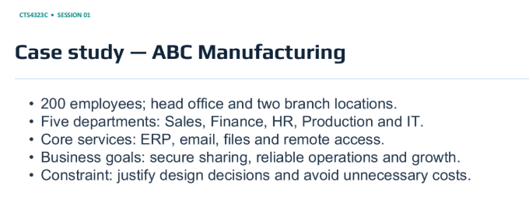
Activity 1 – Discover Requirements
- Head Office 1 + Branch Offices 5 (Sales,Finance,HR,Production,IT)
- 200 employee
- Core Services – ERP system(industry/office system), Shared files, Media Access(media,image,video)

3Qs to com’s manager => Bandwidth, permission, Availability/backup
Requirement Category | Specific Business nees | Technical Impllication
Users & Sites | Head Office 1 + Branch Offices 5 (Sales,Finance,HR,Production,IT) | Scalable network architecture, WAN connection
Core Services | ERP, file sharing, media access | Centralized file server, ERP server, High bandwidth
Backup | Availability | Backup WAN connection, redundant switches
Security | Data safety by department | Firewall, VLAN segmentation, access control list(ACL)

Activity 2 – network plan
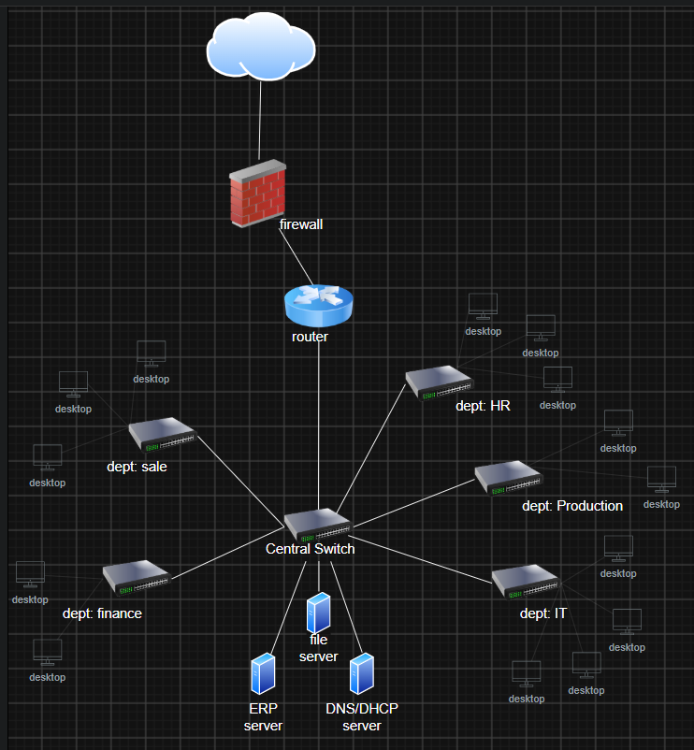

Activity 3 – Explain the trade-offs
- Star topology ( collect the server in the central office and separate department can access to the central, it can save cost too)
- Employee by different branches/department can get access to servers by secure Site-to-Site VPN connection
- ERP and file sharing service are the most important for the business. If there is internet outage happen, these must keep working by redundant backup line.
- The bottleneck can be happened at central switch. For security risk, it need to separate VLANs by firewall rule.
- If doubled the quantity, bandwidth, router and switches must be upgraded.

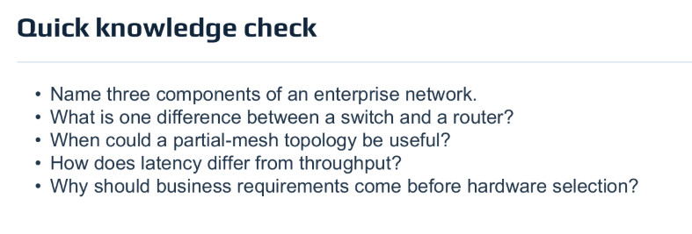

Session 3
Calculate Total IPs & Usable IPs
/Prefix
Eg. /24 = 2^(32-24)=2^(8)= 2x2x2x2x2x2x2x2= 256-2=254(usable IP)
- Usable IP = Total IPs – 2 (2 here represent network address and broadcast address)
- $\text{Total Addresses}=2^{\left(32-\text{prefix}\right)}$

prefix | 32-prefix | Binary Calculation (2^leftover) | Total address | Usable for computer
/24 | 32-24 = 8 | 2^8 | 256 | 254
/25 | 32-25 = 7 | 2^7 | 128 | 126
/26 | 32-26 = 6 | 2^6 | 64 | 62
/27 | 32-27 = 5 | 2^5 | 32 | 30
/28 | 32-28 = 4 | 2^4 | 16 | 14

Subnet Mask
/24 = (the first 24bits are turned ON)
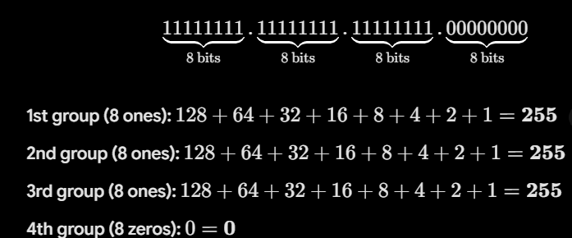
S0 subnet for /24 is 255.255.255.0
For /25 = 11111111.11111111.11111111.10000000 = 255.255.255.128
For /26 = 11111111.11111111.11111111.11000000 = 255.255.255.192
For /27 = 11111111.11111111.11111111.11100000 = 255.255.255.224
For /28 = 11111111.11111111.11111111.11110000 = 255.255.255.240

/27 => 32 addresses
Network address (very first address of the block) 192.168.10.64
Broadcast address (very last address of the block) 192.168.10.127
- Start address + total address -1 = Broadcast Address
- 64 + 64 -1 = 127
First usable = 192.168.10.65
Last usable = 192.168.10.126
For 100 hosts = /25
For 50 hosts = /26
For 25 hosts = /27
For 12 hosts = /28
10% growth changes => 100 + 10% = 110 = /25
50 + 10% = 55 = /26
25 + 10% = 27.5or28 = /27
12 + 10% = 13.2or14= /28 or /27

224 = 2|224|
112|0
56|0
28|0
14|0
7|0
3|1
1|1
0|1
11100000
138+64+32+0+0+0+0+0=224

CIDR = classes inter-domain routing

192.168.10.128 => network ID = 192.168.10.128
Broadcast ID = 192.168.10.191 (128 + 64 -1 = 191)

192.168.20.96/27 => total addresses = 32
Network address = 192.168.20.96
Broadcast address = 96 + 32 -1 = 127 = 192.168.20.127
First usable = 192.168.20.97
Last usable = 192.168.20.126
3 Official private IP ranges => 10.0.0.0 /8 (Huge networks)
172.16.0.0 /12 (Medium-to-large networks)
192.168.0.0 /16 (Small home or office networks)
NAT = network address translation (IPs cannot go straight onto the internet)
VLSM = variable-length subnet masking
Slide 30
Usable hosts for /26 = 64 -2 = 62
Broadcast address of 192.168.10.64 /26 = 64 + 64 -1 = 127 = 192.168.10.127
Use DHCP for client devices = it automates handing the IP addressing for hundred of PCs instead of admin
Branches need non-overlapping IP address = it helps the routers in sending the data exactly and make sure data not get lost and the safe traffic.

Session-4
Routing, DHCP, DNS
Routing => same local network = send data directly
Different network = default gateway(different subnet)
Router’s routing table(connected routes, static routes, default route)

DNS = Domain name system
- Translate name to IP address

DHCP = Dynamic Host Configuration Protocol (automatic setup)
- DORA process
- 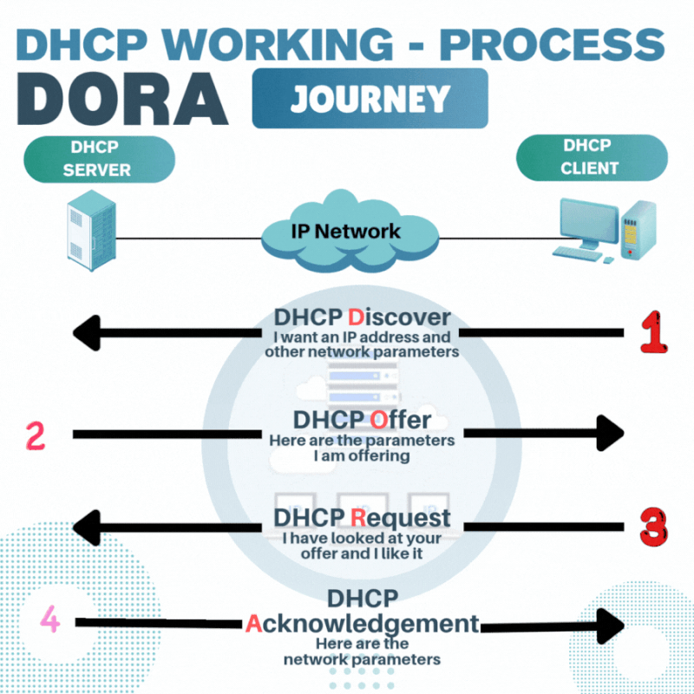
- DHCP relay problem (ip helper-address <DHCP_SERVER_IP>)

Qs(slide-29)
- Why does a host use a default gateway?
To send data to different network or subnet.
- What does an A record contain?
It maps/connect readable hostname to computer understandable numerical IPv4 address.
- What does DHCP provide?
It automatically set IP address, subnet mask, default gatewat and DNS server to client device.
- Why use an (ip helper-address) in our LAN B?
Because DHCP discovery message cannot cross the router by its own, that helper command (ip helper-address serverIP) acts as a relay to forward client requests to DHCP server on another subnet.
- What is the first test when DNS appears to fail?
Pind the IP address directly. If it work or reach the server by IP address not by it’s name, the problem is DNS not network connection.

62.169.19.109 (aka.vn)

Session05
Ethernet LAN essential => ethernet frame ( source and destination addresses)
Switch use MAC table for forwarding ( layer2 learns source MAC addresses)
Eg. PCA (LAN-A) => switch (switch record that source MAC) => of the destination MAC in its MAC table = forward that frame to related PC (LAN-B) / if not forward that frame to all PCs in (LAN-B) and update its table with responding MAC
Switch learns the source MAC addresses and incoming ports
----------------------------=---------------------
Single local network = boradcast traffic floods everywhere (others can see your raw traffic), management has zero control
VLANs(virtual local Area Networks) = Devices in different VLANs cannot talk to each other directly.

How Switch Handle Traffic => MAC learning (switch learns the source MAC and incoming port)
- Flooding ( if the switch don’t know where the destination MAC is, it broadcast the frame to all the devices in that LAN and update its table with the responding one)
- Broadcast domains ( VLAN create separate broadcast boundary)
Qs(Slide 30)
- Switch learn the source MAC address and the incoming port.
- They both connected the end devices and Access port carries traffic for single VLAN. But Trunk carries traffic for multiple VLANs across switches or routers.
- Because VLANs are separate layer 2 broadcast domains and the traffic must pass through a router (layer 3 gateway) to cross between the different subnets.
- It tells the router subinterface to tag and accept traffic belonging to VLAN20 using the IEEE 802.1Q trunking standard.
- No, VLAN only separates the layer2 traffics. By default, the router with route traffic between all VLANs unless you block them later using the security rules like firewalls

